Strategic Partner Program FAQ
What is the Strategic Partner Program (SPP)?
The Strategic Partner Program is Sun Life’s advisor recognition and growth program designed to reward production, engagement, and commitment to delivering strong client outcomes. It provides access to tiered benefits, tools, and support to help grow your business.

How is the new 2027 Strategic Partner Program different from the previous program?
The 2027 program has been modernized to better reflect advisor needs and business priorities. Key enhancements include:
- Product weighting gives advisors more credit toward qualification, helping them reach program levels with lower actual FYC
- A more transparent and structured qualification model
- Enhanced tiered benefits that better support advisors
- Provides opportunity for every advisor

Overall, the new program is designed to be clearer, more relevant, and more supportive of your day-to-day business.

Eligibility & Participation
Who is eligible for the Strategic Partner Program?
All contracted advisors placing eligible insurance business with Sun Life are automatically considered. No enrollment is required.

Qualification
How do I qualify for the program?
Qualification is based on:
- Production
- Product quantity
- Product mix
Based on your results, you will qualify for one of four tiers within one of two tracks:
Tiers
- Emerging “New”
- Partner
- Select
- Premier
Tracks – Track 1 and Track 2 give advisors different ways to qualify, benefits are not based on tracks.
Track 1:
- Targets advisors with broad product portfolios across multiple business lines.
- Emphasizes product count and diversification (requires three different products to qualify).
Track 2:
- Maintains presence in large-case market.
- Advisors only require 1 product count.

Advisors qualify for our Strategic Partner Program in one of two ways: Track 1 or Track 2
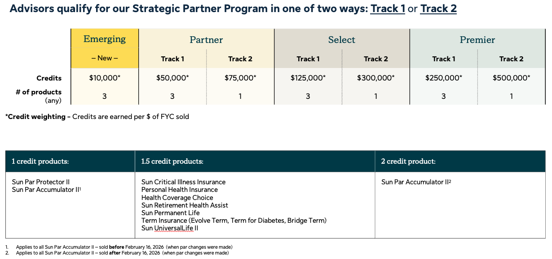

What does qualification look like if I’m a part of a group?
In most cases, qualification is based on your individual results.
Where group-based qualification applies, clear guidelines will outline:
- How production is combined
- How levels are assigned

Groups can qualify for the Strategic Partner Program
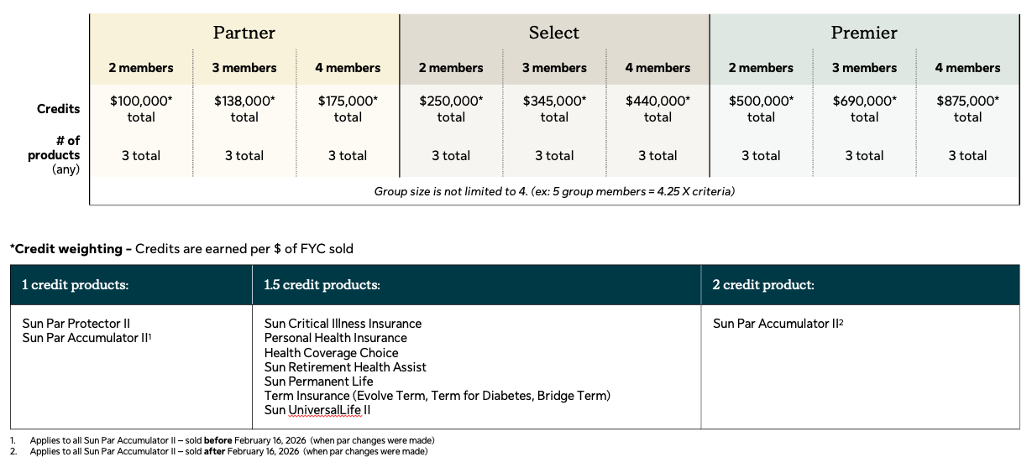

Group FYC Formula is calculated as follows:
- 2 members = 2 x single advisor criteria
- 3 members = 2.75 x single advisor criteria
- 4 members = 3.5 x single advisor criteria

Multi advisor entities have adjusted qualification criteria to account for the number of advisors in the program.

What is the difference between a qualification year and a benefit year?
- Qualification Year: When your production is measured
- Benefit Year: When you receive the benefits tied to your qualification
For example, 2026 production determines your 2027 benefits.

Production & Weighting
How does product weighting work?
Certain products may be weighted more heavily for qualification purposes.
For example:
- Some products may receive increased weighting
- Others remain at standard weighting
This impacts your qualification level, not your actual earnings.

For a policy with zero FYC, will the product be considered towards the required product count?
Yes, the product would be considered and would remain for SPP status.

Will product weighting be applied to a policy with a negative FYC?
No, product weighting will not be applied to policies with a negative FYC.

Tracking & Visibility
Where can I find my qualification status?
Connect with your Sun Life Relationship manager and they can provide you with an update.
Eventually - you can track your progress through Sun Central, including production, tier progress, and qualification status.

Can I move between levels during the year?
Your official level is set annually, but you are able to level-up during the year – This is recorded on a monthly basis.

Benefits
Are there any changes to the tier benefits?
A full suite of new benefits will be introduced to better support your business. Benefit details will be announced in Fall 2026.

