Help Clients get the coverage they need and grow your business with a new limited-time Universal Life (UL) compensation bonus offer. You can earn bonus commissions of 10-15% when you submit 2 or more SunUniversalLife II applications during the offer window. The offer will be available for applications received between October 5, 2026, and June 30, 2027. There are 2 tiers of commission bonus available.
Tier 1 - 10% First Year Commission (FYC) Bonus: Any advisor that submits 2-4 SunUniversalLife II applications during the campaign window will be eligible to receive a 10% first year commission bonus for the Sun Universal Life II applications submitted during the campaign window. A minimum of 2 SunUniversalLife II policies must settle and remain in-force for a 1-year qualifying period before the bonus is paid.
Tier 2 - 15% First Year Commission (FYC) Bonus: Any advisor that submits 5 or more SunUniversalLife II applications during the campaign window will be eligible to receive a 15% first year commission bonus for the SunUniversalLife II applications submitted during the campaign window. A minimum of 5 SunUniversalLife II policies must settle and remain in-force for a 1-year qualifying period before the bonus is paid.
Want to know more?
Read the Frequently asked questions below for details.
Act soon to help Clients get the coverage they need and make the most of this limited-time opportunity. This offer is only available for applications received betweenOctober 5, 2026 – June 30, 2027.

Frequently Asked Questions

Campaign eligibility and timing

Q. Which type of application is eligible for the commission bonus?
A. The commission bonus is eligible for new business applications and conversion applications.

Q. Which products are eligible for the commission bonus?
A. The commission bonus only applies to new SunUniversalLife II policies and Term-to-SunUniversalLife II conversion policies.

Q. What is the campaign timeframe?
A. The campaign is available for applications received by Sun Life Head Office between October 5, 2026, until June 30, 2027.

Q. Where can I find the date from which the 12-month qualifying period starts?
A. The settle date (or issue date) can be found by accessing the client portfolio tool.

To access the client portfolio tool from suncentral, hover over the ‘Client Service’ dropdown menu and select 'Client Portfolio’ from the Quick links menu on the left-hand side.

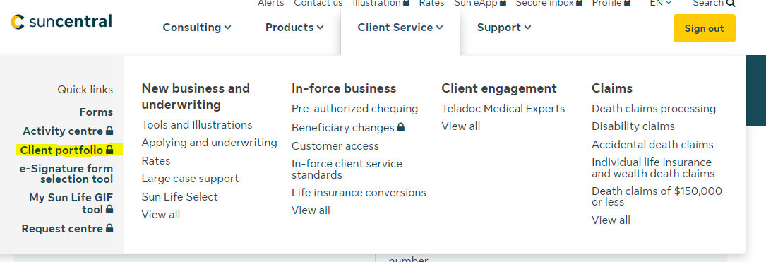

After clicking the link to view the client portfolio, the screen below will appear. Enter the contract number and click ‘Search’

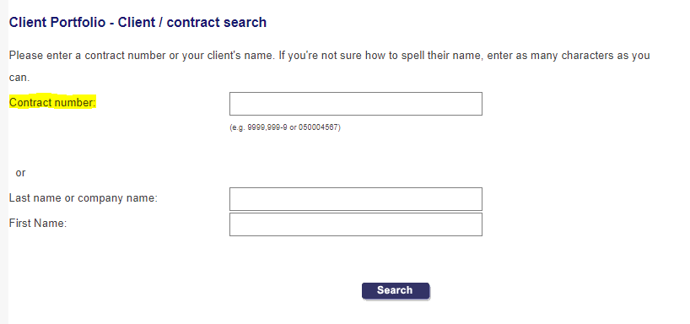

If the contract has a separate owner and insured, you will see the screen below and you will be asked to select which client portfolio you wish to view.

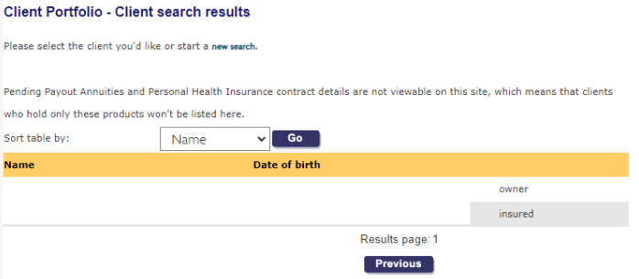

The entire file of client policies will display. Identify the new policy that applies to the UL compensation offer. In the right-hand column, “Issue Date” will display. This date determines when the 12-month qualifying period begins. The qualifying period begins from the issue date of the eligible policy. If the policy was backdated, the qualifying period will not be backdated, and the original issue date will be used to calculate the qualifying period.

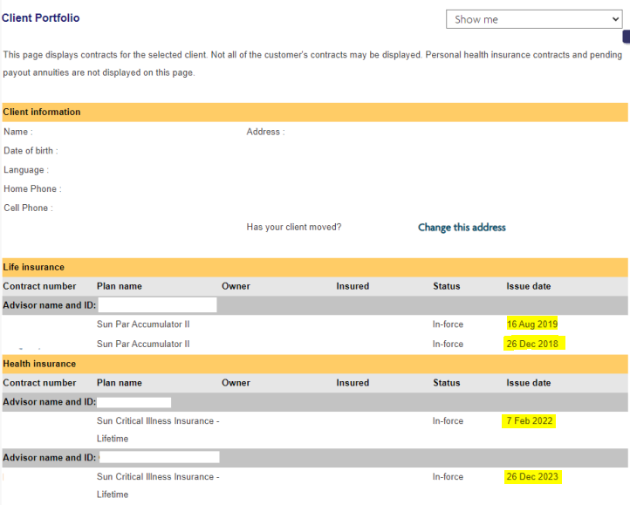

Q. Am I allowed to backdate the policies?
A. Yes. If a client wishes to backdate the SunUniversalLife II policy, they may do so. Backdating is allowed on SunUniversalLife II policies up to 10.5 months with existing backdating rules. If a policy application is received outside of the offer period and backdated for a date within the offer period, that policy will not be eligible for the commission bonus. The application must be received during the offer period to be considered eligible for the commission bonus.

Q. How do I determine the percentage that will apply to calculate my bonus compensation amount?
A. There are two tiers of bonus. If an advisor submits 2-4 SunUniversalLife II policies within the offer period that are issued and remain in-force for a minimum period of 1 year from the settle date, that advisor will qualify for a 10% bonus commission on those policies. If an advisor submits 5 or more SunUniversalLife II policies within the offer period that are issued and remain in-force for a minimum period of 1 year from the settle date, that advisor will qualify for a 15% bonus commission on those policies.

Q. How do I determine the amount of the commission bonus I will receive?
A. Once it’s been determined if a 10% or 15% bonus commission is applicable to a group of policies, this percentage will be multiplied by the total of the FYC and override amount paid for each eligible policy. This will determine the total bonus amount payable as a bonus for each policy. The override portion of the bonus will be split between each advisor and their firm based on the current portion of override each one normally receives.

Q. When will the commission bonus be paid?
A. The commission bonus will be paid in Q3 of 2028, provided that all of the Universal Life policies applied for during the offer period that have remained in-force, have been in-force for at least 1 year.

Q. If I submitted applications that qualify for the UL Compensation Bonus, will these policies also count towards the SPP Loyalty Bonus Strategy?
A. Yes, any policies that qualify for the UL Compensation Bonus will also be eligible to count towards the SPP Loyalty Bonus Strategy.

Q. Is there a minimum or maximum amount for the commission bonus?
A. Yes. There is a $500,000 maximum bonus amount per advisor. This is a maximum bonus amount for the entire offer, including bonuses based on FYC and override for all eligible policies combined. There is no minimum amount.

Q. If the Sun Universal Life II policy lapses during the first 12 months, will it still be eligible for the commission bonus?
A. No, the SunUniversalLife II policy must remain in force for 12 months from the settle date for the commission bonus to apply.

Q. How do changes in coverage amount/policy changes made during the eligibility period affect the amount available for the commission bonus?
A. The commission bonus will be based on the actual amount of First Year Commission (FYC) paid on each eligible policy.

Q. Are there any restrictions on coverage or premium amounts for the SunUniversalLife II product?
A. Yes. The standard product minimums and maximums apply for the SunUniversalLife II product.

Policy Eligibility

Q. Are eApp and paper applications eligible?
A. Yes. All applications formats are eligible for the commission bonus offer; however, we strongly recommend using the Sun eApp for a smoother, more efficient process. Resources are available on the Sun eApp landing page.

Q. Are Sun Universal Life II policies that have not yet settled eligible?
A. No. Any application in underwriting when the campaign begins, or that is approved but not yet settled, will NOT be eligible for the commission bonus. NOTE: Any application that is cancelled and re-submitted during the campaign period to qualify for the offer will not be deemed eligible for the commission bonus.

Q. Can the ownership of the new SunUniversalLife II policy be changed during the 12-month qualifying period?
A. Yes, the ownership of the new policy can be changed during the 12-month qualifying period.

Q. Do I need to submit a cover letter to indicate that the policy submitted should be included in the commission bonus offer?
A. No. Please do not include a cover letter solely to indicate that the policy is eligible for the commission bonus campaign, as this will stop straight through underwriting and processing and will cause service delays. If there is another valid reason to include a cover letter, please continue to do so.

Q. Are policies that are special quoted for more competitive rates or higher face amounts eligible for the advisor commission bonus?
A. These policies will be evaluated on a case-by-case basis to determine if the advisor bonus can apply from a profitability perspective.

Questions?
Please reach out to your Sun Life representative or email us.

